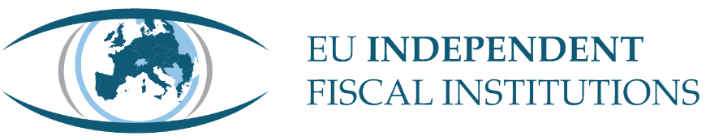

EUROPEAN FISCAL MONITOR

Already Under Strain: The New Fiscal Framework and Defence and Energy Pressures
Summer 2026

Foreword
This Summer 2026 edition of the European Fiscal Monitor is published at a testing juncture for Independent Fiscal Institutions (IFIs) and their role safeguarding sound public finances. While defence spending has largely been accommodated within the framework through the national escape clause, its effects are increasingly visible where the clause does not apply: a number of IFIs now regard the medium-term debt and deficit trajectories embedded in national plans as insufficiently credible, notwithstanding formal compliance with the net expenditure path. The clause has functioned as intended; it has not altered the underlying fiscal arithmetic of higher defence expenditure, and IFIs across the Network are consistently noting this risk.
This is not, however, an isolated test of the framework’s flexibility. Since its activation, a second and distinct pressure has emerged — the energy price shock following the closure of the Strait of Hormuz — for which accommodation has been proposed, and in this geopolitical context further pressures are not implausible. The accumulation of shocks raises a fundamental question: how much flexibly can the framework absorb before the rules themselves become the source of concern?
Moreover, the annual cycle established by the 2024 Economic Governance reform to identify and correct such developments – reporting, verification, formal accounting, and, where necessary, revision – is not yet operating fully as intended at each stage. Several IFIs report uneven quality in Annual Progress Reports and likely deviations from net expenditure paths. The framework is not without effect, but it has yet to perform the corrective function for which it was designed, and this edition suggests the matter warrants closer attention.
These findings do not diminish the case for independent fiscal scrutiny; they reinforce it. In preparing this edition, IFIs across the Network have in many cases gone beyond what the framework formally requires – undertaking assessments on their own initiative, examining figures their own governments might prefer to leave unexamined, and identifying risks well in advance. This is precisely the function such institutions exist to perform. Our Network has recently welcomed its newest member, the Polish Fiscal Council, meaning we are represented in every EU Member State and continue to provide greater scrutiny in safeguarding public finances across the continent.
Lilia Cavallari
Chair of the Network of EU Independent Fiscal Institutions and Chair of the Parliamentary Budget Office, Italy
Esther Gordo Mora  Vice-Chair of the Network of EU Independent Fiscal Institutions and Director at the Spanish Independent Authority for Fiscal Responsibility | Sebastian-Bogdan Căpraru  Vice-Chair of the Network of EU Independent Fiscal Institutions and member of the Romanian Fiscal Council

Contents
Foreword 2
Executive Summary 5
Introduction 6
IFI assessments on the outlook for macroeconomic developments and public finances 7
The macroeconomic environment 7
Public finances 8
Risks to public finances and IFI concerns 12
Challenges faced by IFIs 14
Seasonal focus: IFI perspectives on the Annual Progress Report Cycle 16
Reporting requirements and information quality 17
Monitoring compliance with the Net Expenditure Path 18
Assessment of the control account 21
Assessing the plan's continued credibility 22
Conclusions 25
IFI outlook: a first look at fiscal policy responses to the energy price shocks 25
The nature of the response 26
Estimated fiscal impact 27
How the cost is being treated 28
Annex – Country factsheets 30

Author
This report was authored by Harry Crichton-Miller, secretariat of the Network of EU Independent Fiscal Institutions.
It was reviewed by the Editorial Board and members of the Network. The report is based on survey responses from the members of the Network. The Editorial Board comprises: Bogdan Căpraru (Romanian Fiscal Council), Nicolas Carnot (French High Council of Public Finances), Bernhard Grossmann (Austrian Fiscal Advisory Council), Esther Gordo Mora (Spanish Independent Authority for Fiscal Responsibility), Flavio Padrini (Italian Parliamentary Budget Office), Bert Smid (CPB Netherlands Bureau for Economic Policy Analysis), Natasha Miaouli (Hellenic Fiscal Council), and Lilia Cavallari (Chair of the Parliamentary Budget Office, Italy).
The analysis and views expressed do not necessarily represent the positions of individual members of the Network.

Executive Summary
Independent Fiscal Institutions (IFIs) are national fiscal watchdogs. They assess government forecasts, monitor compliance with European and national fiscal rules, and promote transparency in public finances.
The report comes at a time of growing fiscal pressure and a more complex role for IFIs. The reformed EU economic governance framework has expanded IFIs' mandate, even as governments face mounting spending pressures from defence, ageing populations, climate-related costs, and renewed geopolitical instability — most immediately, the fiscal shock of conflict in the Middle East.
Key findings include:
- Inflation forecasts have become markedly less credible in a single wave (p.8). Linked to the conflict in the Middle East, only 54% of IFIs now rate their government's short-term inflation forecast plausible, down sharply from 78% in December 2025.
- Defence spending remains the dominant fiscal risk for most IFIs, particularly once its temporary shelter is expiring (p.22). IFIs in NEC-activated countries appear more worried about national debt and deficits (p.10).
- IFI concern about key government fiscal activity is rising across the board, not just intensifying in one (pp.13–14). Not a single IFI reported feeling entirely unconcerned about their government's fiscal stance, EU rule compliance, national rule compliance, or transparency; the first time in three years of tracking this has happened.
- A third of IFIs doubt their country's debt will be on a downward path by the end of the adjustment period (pp.23–24). IFIs in nine of 27 countries rate this implausible or very implausible — several citing detailed arithmetic showing debt still rising even under strict adherence to the net expenditure path.
- Looking beyond the current adjustment period, the picture darkens further: More than half of IFIs judge their country's long-term fiscal position unsustainable under current policy (pp.24–25).
- The Annual Progress Report cycle is only partly delivering on its purpose (pp.18–19, 25–26). Information quality in particular is uneven.
- The energy crisis policy response has skewed broad-based rather than targeted, against explicit IMF and ECB guidance (pp.27–28).

Overall, the picture this edition paints is one of a framework functioning, but under increasing strain. Compliance mechanics are active and IFIs are frequently doing more than the rules formally ask of them, yet the same underlying pressures – most consistently, compliance with net expenditure and defence-linked spending – occur repeatedly across the survey without yet prompting the corrective action the framework was designed to trigger. Sustained, independent fiscal oversight – properly resourced and with genuine access to information – remains essential to ensuring that this strain is identified and addressed proactively and comprehensively.

Introduction
The European Fiscal Monitor is a biannual report offering a regular, timely snapshot of the perspectives, challenges and work of the Independent Fiscal Institutions (IFIs) in the EU IFI Network. IFIs form an important part of any national fiscal framework, serving as national ‘fiscal watchdogs’ that bring high-quality, objective research to increase fiscal accountability. They have been a central part of European national fiscal frameworks since 2011, with their work focussing on monitoring government compliance with national and EU fiscal rules, producing or endorsing macroeconomic forecasts, providing analysis to governments on fiscal issues, and communicating their findings to the public.
The 2024 reform of the EU economic governance framework expanded this mandate further, particularly through Directive (EU) 2024/1265, which enhances national ownership of fiscal policy while involving IFIs more substantively in the preparation, assessment and monitoring of national fiscal plans and their compliance with EU fiscal rules. The deadline for Member States to transpose this Directive was 31 December 2025.
Since the reform's introduction, the fiscal environment has grown more complex. The fiscal implications of climate change and demographic ageing have become more pressing, defence spending commitments have sharply risen amid renewed geopolitical instability, and a fresh energy price shock – set off by the Iran conflict – has required triggered fiscal responses in real time, even as Member States work through adopting the new governance framework into national law.
This report gathers IFIs' own perspectives on this challenging environment, drawing lessons from across the network's varied experience. It should not be read as a formal assessment of Member States' transposition of the Directive, nor of the wider European fiscal outlook.
This edition draws on a survey of 32 IFIs across 27 countries – 26 EU Member States and the UK – conducted from 15 June to 9 July 2026. The report opens with IFIs' assessments of the macroeconomic and fiscal outlook, followed by the risks and challenges facing both public finances and the IFIs themselves. Chapter 4 traces IFIs’ experience of the Annual Progress Report (APR) cycle, before the final chapter offers a first look at fiscal responses to the recent energy price shock. Annex One provides factsheets on individual IFIs' recent activities.

IFI assessments on the outlook for macroeconomic developments and public finances
This section summarises how Independent Fiscal Institutions (IFIs) evaluated the realism and robustness of EU Member States' 2026 official forecasts, and, where available, 2027 and 2028, following the new European fiscal framework’s medium-term horizon. IFIs were asked to express their opinion on the plausibility of the latest available official national forecasts. Each figure plots the forecast for the three years, coloured according to how far IFIs found the forecast plausible.
There are several caveats regarding coverage: Spain’s IFI answered ‘don’t know’ to all short-term indicators, reflecting the fact that Spain’s 2026 APR contained only a partially updated macroeconomic forecast, and that Spain has not submitted a 2026 Draft Budgetary Plan. In the medium term, growth forecasts drop from 26 to 22 countries, reflecting five governments (Austria, Croatia, Germany, Malta and Slovakia) that have not published updated projections beyond 2026, while nine countries do not report fiscal forecasts in the medium term (Belgium, Croatia, Denmark, France, Germany, Greece, Malta, Slovakia, Spain).

The macroeconomic environment
Figure 1. IFIs’ assessment of real GDP growth projected for 2026-2028 (%)
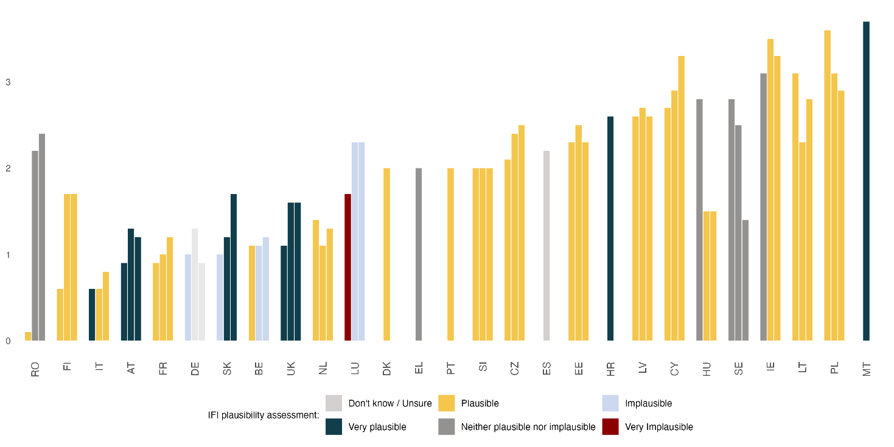Source: The Network of EU Independent Fiscal Institutions (2026), based on official national forecasts. N=27.

Figure 2. IFIs’ assessment of annual inflation projected for 2026-2028 (%, GDP deflator)
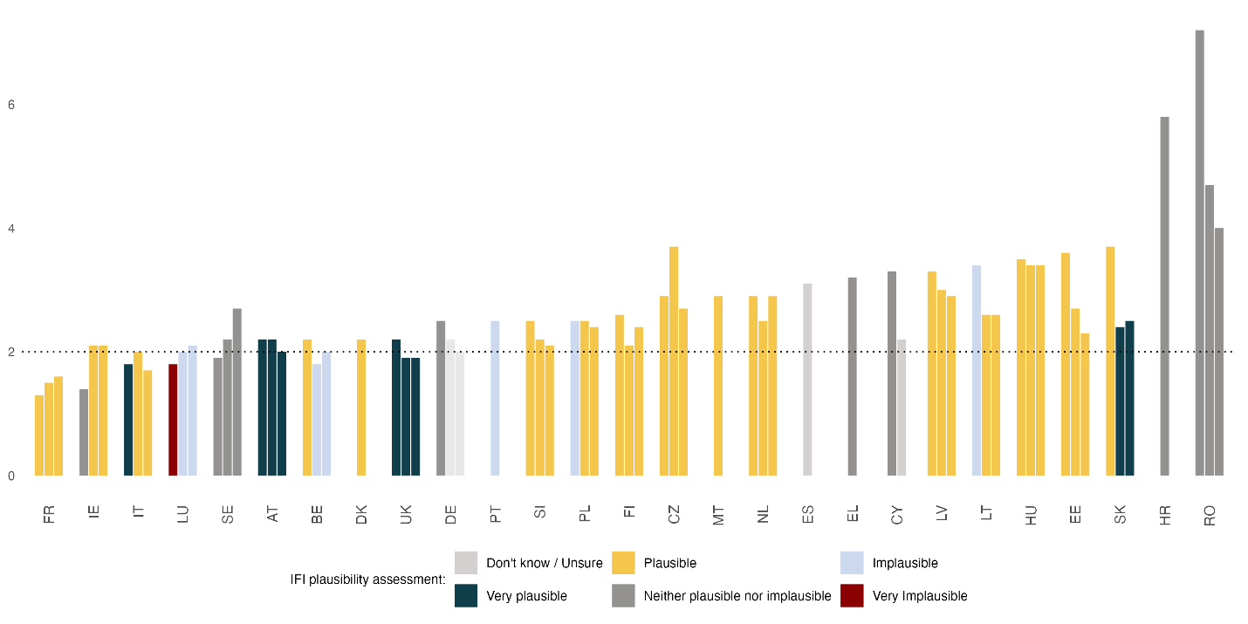Source: The Network of EU Independent Fiscal Institutions (2026), based on official national forecasts. N=27.
Inflation is the least plausible short-term indicator for IFIs, with only 54% of the 26 respondent countries rating the government’s inflation forecast plausible or very plausible, compared to 65-92% for the other five indicators. This is a new and significant fall; by comparison, nearly 78% of IFIs found the short-term inflation estimate to be reasonable when asked the same in December 2025.
The conflict in the Middle East is likely driving this deterioration in the plausibility of inflation forecasts across the EU-27. Five IFIs (Netherlands, Germany, France, Lithuania and Poland) explicitly make the connection to the conflict in the Middle East and the associated energy price shock. Indeed, this inflationary shock occurred as some governments were finalising their forecasts, which some IFIs stress may have otherwise been plausible (France and Poland). For others, recent geopolitical events have made it difficult to properly judge the accuracy of existing forecasts, owing to the highest number of ‘neither’ results.
Looking beyond the next year, medium-term inflation forecasts are largely found to be plausible, which is in line with previous editions. Yet they are also expected to be above target – with 24 of 26 surveyed projected to have inflation above 2%, of whom, 10 expect inflation more than 0.5 percentage points (pp) above target. Such a finding implies a concerning, but soberly approached, inflationary situation across the EU-27.

Public finances
IFIs’ assessment of European public finance forecasts again suggests a more mixed picture compared to the macroeconomic environment. While in the short run, projections are largely deemed plausible (19, 18 and 17 out of 26 IFIs find forecasts for public debt, government balance and net expenditure plausible in 2026), the medium-term forecast is viewed considerably less positively. Only half of IFIs find the medium-term forecast for the general government balance plausible, and fewer than half find the forecasted public debt and net expenditure paths plausible.
Both public debt and government balance have ‘very implausible’ tails in both the short and medium term, with the same three each in the short term (the Czech Republic, Hungary and Luxembourg), and the same two (the Czech Republic and Hungary) in the medium term.
Luxembourg's IFI attributes its scepticism to the Ministry of Finance having not updated its 2026 figures for the APR at all, though finds the forecasts only implausible in the medium term. In the Czech Republic, government bill 90/0 (pending Senate approval as of June 2026) would relax budgetary discipline in a myriad of ways that have prompted concern for the state of Czech public finances – a 10% allowance to exceed expenditure limits during a ‘national emergency’ and an extension of the defence-spending escape clause from 2033 to 2036. If passed by the Senate, public finances would automatically deteriorate relative to the April forecast.
The Hungarian IFI’s plausibility assessment was made without a current-cycle APR, due to the change of government. The new government is expected to review the Medium-Term Fiscal-Structural Plans (MTFSP) by autumn 2026, perhaps including corrective actions (in line with its plan to adopt the euro). However, a gap of 1.1pp between the Hungarian MTFSP and the country’s current debt trajectory has already opened, and is expected to widen over this year, driving the Hungarian IFI’s assessment.
Figure 3. IFIs’ assessment of the general government balance projected for 2026-2028 (% of GDP)
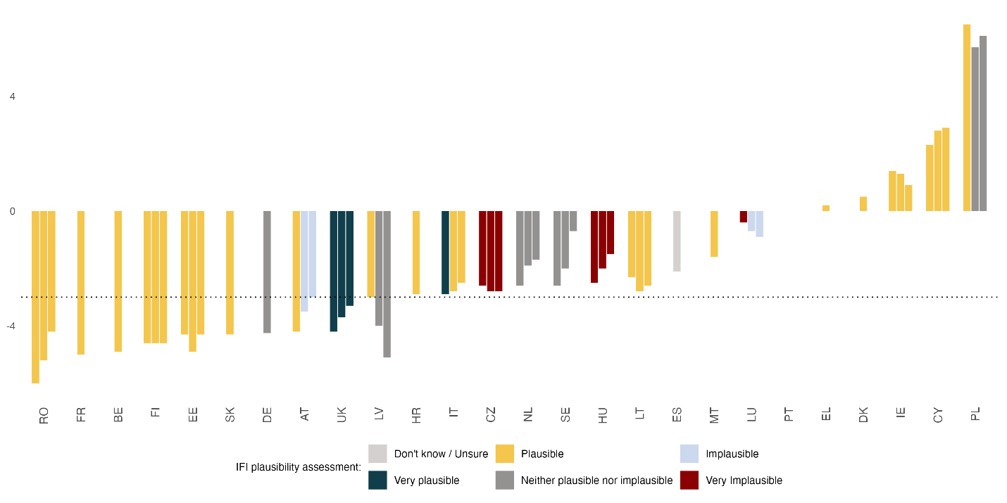Source: The Network of EU Independent Fiscal Institutions (2026), based on official national forecasts. N=26.
Looking in more detail at the forecasts themselves, most countries forecast a deficit, as in previous years, with ten countries expected to run a deficit above the 3% of GDP reference value, with several other member states running close. Similarly, most public debt-to-GDP ratios have modestly climbed in comparison to previous recent European Fiscal Monitors, with fourteen countries now expected to exceed the 60% ‘debt rule’ reference value. The shape of forecasted debt is also concerning: Only four countries’ debt-GDP levels are forecast to fall between 2026-28 (IE, CY, HU, IT), with the Hungarian IFI further finding this forecast very implausible, though EU fiscal rules only require a plausibly downward path ‘by the final year’ of the adjustment period.
18 Member States have now activated the National Escape Clause for defence expenditure (‘NEC’), of which seven are expected to exceed the SGP deficit reference value and ten to exceed the SGP reference value in any year in the next medium-term reference period. While the 2024 reform (Reg. 2024/1263) established the net expenditure path as the single key operational fiscal rule, the fact that a large number of countries are forecasted to exceed these reference values is cause for concern. Yet, though the prospect of greater deficits and public debt, driven by defence spending, looms, the forecast government balances and debt-to-GDP ratios are largely similar to in previous years, suggesting that expenditure commitments are yet to materially impact public finances.
Figure 4. IFIs’ assessment of gross public debt on the Maastricht basis projected for 2026-2028 (% of GDP)
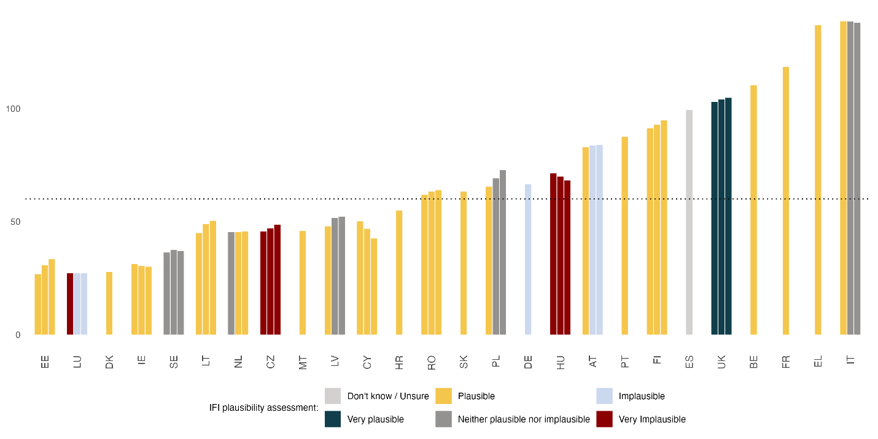Source: The Network of EU Independent Fiscal Institutions (2026), based on official national forecasts. N=26.
Consistent with previous Fiscal Monitors, IFIs find forecasts on interest expenditure to be the most plausible, with only the Maltese IFI finding it implausible. According to these forecasts, interest expenditure as a proportion of GDP will remain highest in Italy and Hungary, with interest payments also expected to cover more than 3% of GDP in Poland, the UK, Greece and Romania. Perhaps interestingly, interest expenditure is expected to fall modestly across the board compared with the Fiscal Monitor’s most recent edition, in part driven by a fall in Hungary’s expenditure as a share of GDP. Several IFIs stress that such plausible assessments are contingent on public finances not deteriorating any further.
Figure 5. IFIs’ assessment of interest expenditure on public debt projected for 2026-2028 (% of GDP)
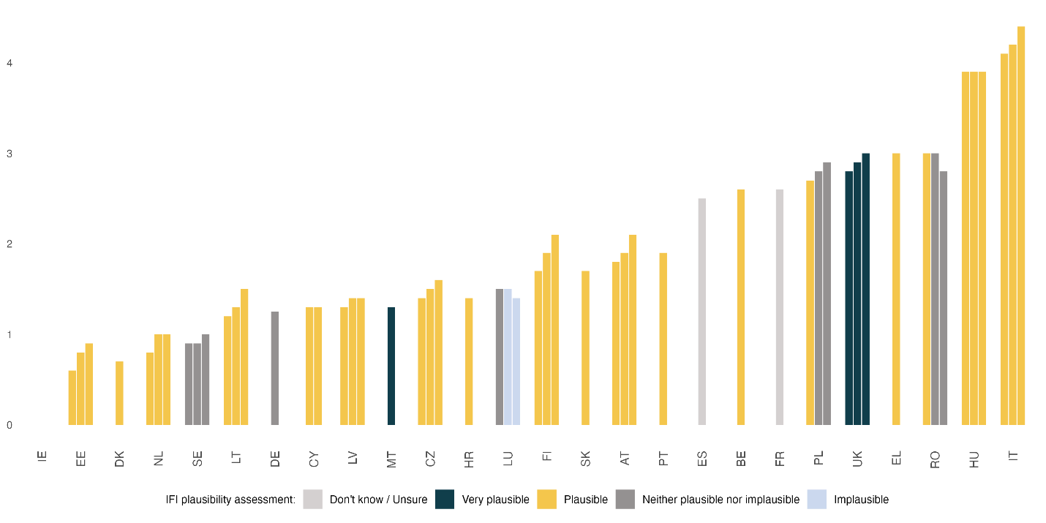Source: The Network of EU Independent Fiscal Institutions (2026), based on official national forecasts. N=25.
An emerging descriptive pattern across these forecasts is that, at first glance, NEC activation appears to be associated with a medium-term deterioration in debt and government balance plausibility. Taking the mean assessment of all six indicators in the medium term for the countries that have activated the NEC and those that have not, IFIs in NEC-activated countries find government balance and debt-to-GDP ratios to be 0.3 and 0.4 less plausible, on a scale of five. This difference disappears entirely in the short run (+0.10 and +0.00 respectively) – consistent with the fact that debt and deficits will grow in proportion with increased military expenditure over the medium-term.
Table 1. Mean IFI assessment of key indicators in the medium term, and difference. Scores are country-level plausibility ratings (1 = very plausible … 5 = very implausible); a higher score is less plausible.
Indicator | NEC activated (n=17) | NEC not activated (n=9) | Difference
GDP | 2.00 | 2.50 | -0.50
Balance | 2.90 | 2.62 | +0.27
Debt | 3.00 | 2.62 | +0.38
Inflation | 2.00 | 2.57 | -0.57
Interest expenditure | 2.20 | 2.57 | -0.37
Source: The Network of EU Independent Fiscal Institutions (2026), based on official national forecasts. N=26.
To some extent, it is to be expected that NEC-activated countries may look to run a larger deficit or have higher debt; the NEC explicitly allows a country to exceed its net expenditure ceiling for defence spending without being judged non-compliant, but that extra spending will still weigh on the deficit and debt figures and, to some extent, fiscal sustainability in those member states.

Risks to public finances and IFI concerns
IFIs were asked to rate the importance of several key categories of fiscal risk, in the short and medium term (Figure 6). Read together, the responses trace a consistent increasing concern as the time horizon lengthens, though this differs materially by risk category.
Figure 6. Risks to public finances, share of IFIs in the short (2026, LHS) and medium term (2027-2028, RHS)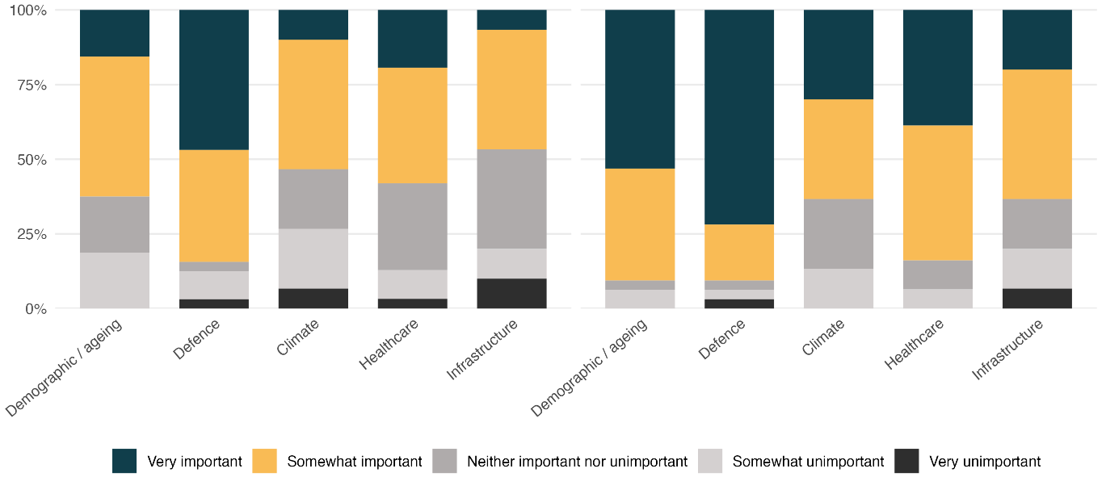
Source: The Network of EU Independent Fiscal Institutions (2026). N=31.

As is consistent with the rest of this report and previous editions, defence expenditure is the dominant short-term risk to public finances. Fifteen of 32 IFIs rate it very important in the short term, rising to 23 out of 32 in the medium term, consistent with concerns over the NEC’s expiry for defence expenditure requiring steep fiscal adjustment and driving a medium-term deterioration in public finances.
Demographic and ageing pressures show the steepest rise of any category as the horizon lengthens: five IFIs rate this very important in the short term, climbing to 17 in the medium term. This is the clearest directional trend in the risk data. Healthcare cost growth follows a broadly similar upward path, from six IFIs in the short term to 12 in the medium term and 11 out of 31 in the long term, with the bulk of respondents rating it ‘somewhat’ rather than ‘very’ important – a persistent but comparatively moderate concern rather than an acute one. Infrastructure is the only category that does not show a clear monotonic rise: two IFIs rate it very important in the short term and only six in the medium term – the lowest long-term reading of any category, and one that would benefit from free-text follow-up to establish whether this reflects genuine reassurance or simply a narrower long-term framing of the question.
IFIs were also asked for their level of concern over various key elements of their own governments’ fiscal behaviour, to identify high-level worries across the Network. With this question having been asked to IFIs annually since the Summer 2024 edition, this allows for a time-series to be constructed that plots the evolution of IFIs’ concerns over the past two years. Such a period is of interest, because the EU’s new Economic Governance Framework came into effect shortly before the first wave, and the deadline for Member States to transpose it into national legislation occurred in December 2025, between the second and third waves.
Figure 7 breaks down the level of concern each year for each main concern: the government’s chosen fiscal stance, its potential for (non)compliance with national and EU fiscal rules and the government’s transparency in communicating around these concerns. To prevent double-counting, countries with two IFIs have had their responses averaged.
Figure 7. Degree of concern expressed by IFIs about governments’ key fiscal behaviour in the short term
Source: The Network of EU Independent Fiscal Institutions (2026). N=26 (2024), N=27 (2025-6), country averages.
In 2026, The government’s fiscal stance is the highest cause for concern amongst 21 out of 26 IFIs. This is mostly consistent with the 18 countries whose fiscal stance in 2026 IFIs considered expansionary, yet for several countries a neutral stance is still concerning.
Compliance with EU fiscal rules closely follows, with 10 IFIs being highly concerned. This plausibly reflects IFIs’ increasing scepticism regarding the net expenditure growth path, due to increasing spending pressures, especially defence. Yet IFIs are also concerned (17 out of 26) about compliance with national rules, perhaps linked to IFIs' closer institutional proximity to national rule enforcement than to EU-level compliance assessment. Concerns over transparency is comparatively contained (only five IFIs were highly concerned) but not negligible. Such concerns are often linked. For example, Spain's IFI ties its EU/national rules concern specifically to data constraints, citing the absence of an approved 2026 General Budget and only a partial update to the APR's macroeconomic forecast as limits on both fiscal transparency and its own capacity to assess policy.
Set against the past three summer editions, this single-wave picture looks like the sharper end of a broader multi-year trend rather than an isolated reading. Across all four, the share of IFIs reporting no concern at all (‘not concerned at all’) has fallen from a combined six responses across the four domains in 2024 to zero in 2026; by this summer, not a single IFI reports being entirely unconcerned about any of the four areas tracked.
Across the four domains, the proportion of IFIs expressing concern falls moderately in 2025, before rising sharply in 2026. This pattern differs by domain. EU fiscal rules compliance shows this pattern most acutely, while the increase in concern over governments’ fiscal stances is particularly driven by IFIs now being ‘slightly’ concerned. This implies a mild but broadening concern over governments’ expansionary fiscal policy, contrasting with compliance with EU fiscal rules, which has seen an increase in high concern. Such a distinction would be consistent with a path of fiscal expansion that is somewhat troublesome, yet IFIs additionally expect their governments to be in breach EU fiscal rules. Compliance with national fiscal rules rises more steadily across all three waves, consistent with the uncertainty over the design of national fiscal rules in line with the EU’s new fiscal rules. Transparency is the most stable of the four, suggesting this dimension is not tracking the same deterioration as the other three.
Read together, the three-year data suggests 2026 is the most concerned level yet on a trend that has been building since 2024, most visibly on compliance with EU rules and, to a lesser extent, compliance with national rules – with concerns over the fiscal stance broadening in intensity rather than deepening, and concerns over transparency essentially decoupled from the other three.

Challenges faced by IFIs
The Fiscal Monitor now regularly asks IFIs to rate the importance of various challenges to their work in the short term (this current year and the next), to identify common issues across the Network, again allowing time-series data for this important period of the transposition of the new economic governance framework to be presented here.
Figure 8 shows the challenges faced by IFIs in executing their work, centring on historically significant challenges: high (policy) uncertainty, insufficient resources, a lack of clarity from national and EU authorities, and insufficient access to data.
Figure 8. Challenges faced by IFIs in executing their work in the short term, time-series
Source: The Network of EU Independent Fiscal Institutions (2026). N=26 (2024), N=27 (2025-6), country averages.
High uncertainty is the dominant operational challenge (with 24 out of 26 IFIs rating it important in 2026) over the past three years, consistent with political upheaval inside the EU and geopolitical change outside. The jump from an important challenge for only a small minority in 2024, to almost two-thirds in the following year, tracks the escalating geopolitical shocks and their expansionary policy responses referenced throughout this report. A lack of clarity from national/EU authorities follows (18 out of 26 IFIs in 2026), perhaps also tying into this more fraught environment, with changes of government in several countries driving this. Positively, the fall from 2024 to 2026 implies the transposition of the new economic governance framework is at least nominally clear.
Data access and insufficient resources both show the same set of patterns: the overall number of IFIs that see them as important challenges has remained stable or has fallen over the past three years, but the number that see them as acute challenges has risen notably, from two to six for insufficient resources, and two to nine for insufficient data access. Article 8a of Directive (EU) 2024/1265 – designed to strengthen IFIs – includes specific provisions to increase timely access to data and for IFIs to have the necessary resources to perform their tasks effectively. The improvement for some IFIs on resources may be linked to the Directive’s transposition. The acute deterioration for others may imply that around a third of IFIs may not yet have seen boosted resources and data access as required by the Directive, despite an increase in tasks required of them.
Figure 9 asks specifically about IFIs’ capacity to perform these (and other) key functions over the past three Fiscal Monitors (i.e. the past 18 months).
Figure 9. IFIs’ Concern about their capacity to perform key functions, under Article 8a, Directive (EU) 2024/1265
Source: The Network of EU Independent Fiscal Institutions (2026). N varies between 25-27.
Consistent with IFI challenges, adequate and timely data access is both the most concerning dimension in this wave and the one most clearly moving in the wrong direction. In Summer 2026, 15 out of 27 responding IFIs report some degree of concern, eight of them highly so, against eight reporting no concern at all, a sharp rise from Winter 2026, following a fall that implied a brief improvement from Summer 2025. For example, the Network’s newest member, Poland's Fiscal Council, references continuing reluctance by the Finance Ministry to share data, though a Memoranda of Understanding is being concluded, while Ireland's Fiscal Advisory Council describes relying on the goodwill of other bodies to access key information.
Freedom from undue influence and public communication remain, by contrast, the two dimensions IFIs are least concerned about, and both have been consistently so across all three waves. Effective task capacity shows a more volatile pattern than a trend. Ten of 27 IFIs express some concern in Summer 2026, level with the 10 of 25 recorded in Winter 2026, but both waves being markedly higher than the seven of 26 recorded in Summer 2025. The matter of external evaluations, on which the Network has recently published a position paper, is an issue whose practical implementation will likely pose challenges, especially for smaller IFIs, whose limited budget may constrain their capacity to finance and manage an external evaluation.
Several IFIs tie their capacity concerns directly to the state of national transposition. Portugal's CFP reports it cannot yet assess what additional capacity it will need, since transposition of Article 8a has not been completed. Malta's MFAC reports that the Directive remained untransposed into national legislation as of the survey date, that its requests for meetings with the Ministry had gone unanswered, and that it submitted a position paper in October 2025 under its existing statutory obligations. By contrast, Latvia, Finland, Romania and the Netherlands report transposition as complete – the Netherlands ahead of the deadline = and Spain reports that its existing statute already largely satisfied the Directive's external evaluation requirement in practice.

Seasonal focus: IFI perspectives on the Annual Progress Report Cycle
Under the new economic governance framework (and specifically Regulation (EU) 2024/1263), Member States must follow a regular annual economic governance cycle. Starting with Council endorsement of a net expenditure path over the entire adjustment period as part of the MTFSPs, Member States report back each year. By 30 April, they submit an Annual Progress Report covering the implementation of that path and other broader, Semester-linked reforms and investments over the past year. Observed net expenditure is checked against the Council-endorsed path and any deviation recorded in a control account – a role that IFIs may be additionally asked to do by their Member State. For countries in the preventive arm, if deviations are large enough, and other conditions met (e.g. debt above the reference value), an Excessive Deficit Procedure (EDP) based on the debt criterion may be initiated. For countries in the corrective arm, i.e. already in EDP, any deviation would trigger an overall assessment of the Commission to establish whether “effective action” was carried out by the Member State to respect the corrective net expenditure path recommended by the Council.
This chapter seeks to follow IFI perspectives on this full annual cycle of the evolution of the net expenditure path and ensuring fiscal sustainability – from the information reported about it, through to the compliance mechanics that track it, to the questions raised about whether the underlying MTFSP still holds. Some stages show the process working largely as designed, others show friction or open questions, and the chapter tries to be precise about which is which rather than collapsing everything into a single judgement.

Reporting requirements and information quality
Every annual cycle begins with the Annual Progress Report itself. Article 21 requires this document to set out how the net expenditure path is being implemented, alongside broader reform and investment progress linked to the European Semester and, where relevant, the commitments underpinning any extension of the adjustment period. Before IFIs work to understand whether compliance is being judged correctly, it is first important to understand the quality of the information that is shared with them in this report.
The picture is decidedly mixed and varies markedly by content area. On information about net expenditure path implementation specifically, 11 out of 31 IFIs rate it good or very good, 10 rate it merely adequate, and 8 rate it poor – a sizeable minority finding the core reporting item wanting (Figure 10). Information on reform and investment progress fares somewhat better: 12 out of 31 IFIs rate it good or very good, against six rating it poor or very poor. A further item on broader Semester-linked reporting sits in between, with seven out of 31 IFIs rating it good or very good, but also the largest ‘don't know’ response of the three (seven IFIs) – suggesting this is an area several IFIs simply do not yet have a settled view on, rather than one they have assessed and found wanting.
Figure 10. IFIs’ opinion on the adequacy of information in their country’s APR
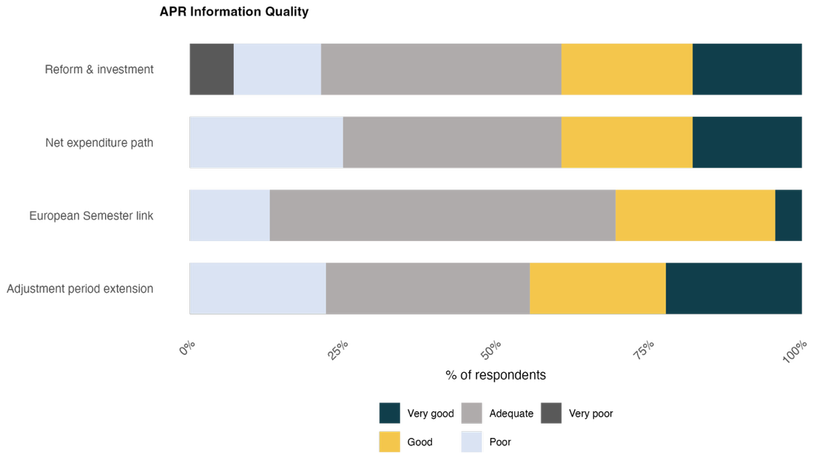
Source: The Network of EU Independent Fiscal Institutions (2026). N=31, including ‘don’t know/unsures’, which are excluded from this figure.
Several IFIs identify the key issue as being one where the APR meets the letter of the requirement while still falling short of what would let them provide proper independent scrutiny. Two IFIs (Luxembourg and Poland) describe their APR as containing only the minimal required content, often missing other crucial context – such as the fiscal assumptions behind the Polish macroeconomic forecast to 2030. One IFI (the Czech Republic) had such a similar experience that they had to go back to their own Ministry of Finance directly to understand how a reported figure was actually calculated, rather than being able to follow it clearly from the published report alone. Others point to specific gaps in disclosure: the underlying components of net expenditure growth not being shown beyond the current year (Italy) or reform measures that justify an adjustment period extension being explained in detail, but without any assessment of the macroeconomic impact (Spain). A few IFIs state that the report is technically complete but that it has narrowed compared to previous cycles, with Slovenia’s IFI noting that a standard medium-term projection it had come to rely on was simply absent from this year's report for the first time, without any explanation. Hungary, as already mentioned, has no Annual Progress Report for 2026.
Read together, these findings suggest the reporting stage of the cycle is functioning, at least in the narrow sense that reports are being produced and made public. However, this is being done so unevenly and in a handful of cases, insufficiently, with several IFIs describing having to supplement the official report with their own follow-up questions or external documents simply to understand what their government has actually committed to.

Monitoring compliance with the Net Expenditure Path
Once an APR is filed, the framework's next job is to check it against what actually happened, and against the plausibility of the assumptions the government used to build it in the first place. Figure 12 shows the gap between the actual 2025 outturn and the relevant forecast in the MTFSP.
Figure 11 compares forecasts on real GDP, inflation, and net primary expenditure growth in each Member State's MTFSP to Eurostat outturn data for 2025. Fifteen of 27 countries recorded net expenditure growth above their MTFSP commitment, against 12 below. Growth forecasts were generally mildly over-optimistic, with around 15 countries’ outturn above their MTFSP forecast, but overshooting by only a small magnitude. Inflation was generally under-estimated (17 above the MTFSP forecast), with prices rising faster than plans assumed.
Read together, these macroeconomic conditions seem to go some way towards mechanically explaining overshoots in net expenditure growth: plans were built on rosier growth assumptions than materialised, and net expenditure ceilings – set in nominal terms – could have been squeezed by higher-than-expected inflation without any change in real spending behaviour. Some countries seem to show this – Bulgaria, Croatia, and Hungary, for instance, all show a large inflation overshoot and a large net-expenditure overshoot, consistent with at least part of this net expenditure deviation being a nominal, inflation-driven effect. Yet several other countries show the opposite pattern – Romania and Estonia both undershot net expenditure by some of the largest margins, despite positive (Romania) and neutral (Estonia) inflation overshoots. Indeed, Sweden overshot inflation by 3.5 percentage points while still undershooting net expenditure growth – suggesting independent spending decisions, rather than inflation, are driving their net expenditure outturn. Overall, higher inflation and lower growth than expected may go some way to explaining part of the net expenditure overshoot pattern, but not all the way – and several of the largest net-expenditure deviations (in both directions) are moving independently of the inflation surprise.
Figure 11. Gap between outturn data and forecast, for Real GDP, Inflation, and Net expenditure growth, 2025.
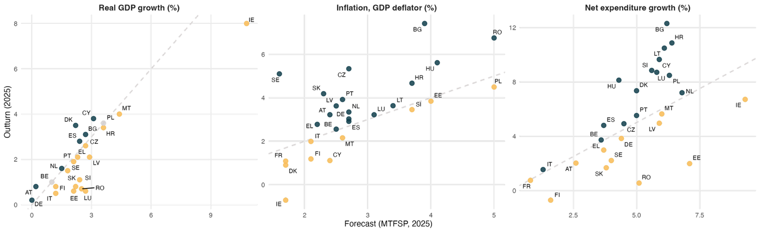Source: The Network of EU Independent Fiscal Institutions (2026). N=27. Points above the dashed line overshot their forecast/commitment in the MTFSP (Blue). Points below it undershot the forecast in the MTFSP (Yellow).
The drivers IFIs cite for these deviations are concentrated and recurring rather than idiosyncratic.
Outturn data exceeding the forecast is often linked to greater contingent ‘off plan’ measures or greater-than-expected increases in current expenditure: Several IFIs point to public sector wage and compensation growth running ahead of plan (Slovenia, Croatia and Portugal). Others cite the continuation of cost-of-living and energy support measures originally framed as temporary (Croatia, Spain), made more costly in nominal terms by ongoing crisis-driven inflation (Croatia, Greece, Spain). In some cases, discretionary spending drives this – the Cypriot IFI attributes its deviation to specific items, such as a solidarity fund, a grant-return on an LNG terminal investment and a solar subsidy scheme, while the Italian IFI attributes the deviation to the ‘Superbonus’ housing tax credits. Defence expenditure is a recurring theme, with both the Polish and Lithuanian IFIs noting that national escape clause defence spending is a direct contributor to their net expenditure figures.
Gaps for both Macroeconomic variables are largely driven by differences in expectations: GDP growth in some cases has held up stronger than expected, driven by robust exports (Cyprus), and merchanting (Denmark), while in others, an international economic environment that is weaker than when originally assumed (Slovenia) and a higher savings rate than forecast (Slovenia) has had the opposite effect, with uncertainty depressing investment and external demand (Hungary). For several IFIs, the energy crisis has driven higher-than-expected inflation (Croatia, Greece, Spain).
Article 23 of Regulation (EU) 2024/1263 notes that IFIs may be optionally requested by governments to provide an assessment of their compliance with the net expenditure growth target and to assess the APR. Positively, 12 IFI respondents report being formally requested to assess compliance and IFIs’ proactive work in this space is evidenced by the fact that a further eight reported having carried out an assessment on their own initiative without being asked (Figure 12).
Figure 12. IFIs involvement in assessing APR (Article 23, Regulation (EU) 2024/1263).
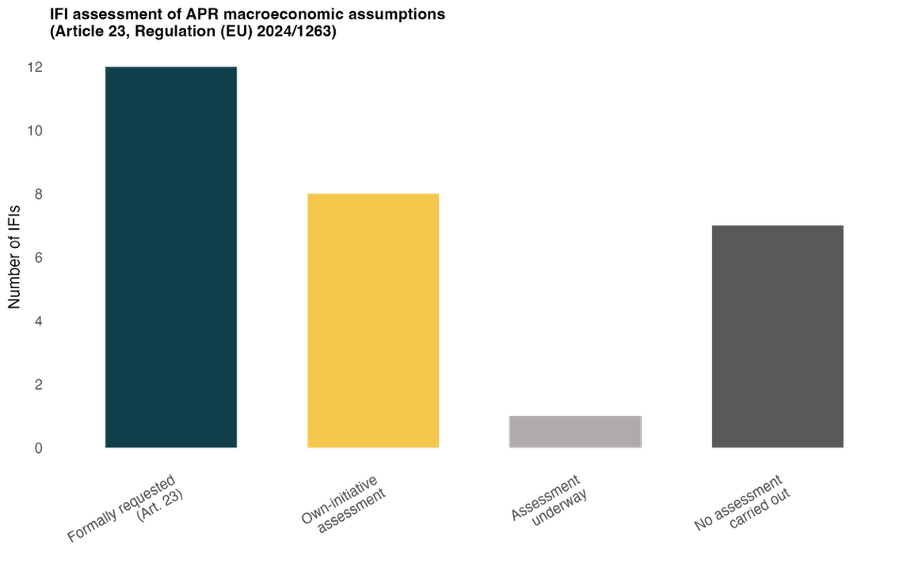
Source: The Network of EU Independent Fiscal Institutions (2026). N=31, including ‘don’t know/unsures’, which are excluded from this figure.
Where IFIs did specifically assess the macroeconomic assumptions, the large majority found them plausible or very plausible (16 out of 22), with only three rating them implausible and none rating them very implausible (Figure 13). However, a large proportion of IFIs (nine respondents) responded do not know, reflecting the earlier data issue in the reporting itself.
Figure 13. IFIs’ assessment of the plausibility of APR macroeconomic assumptions, 2026 (LHS)
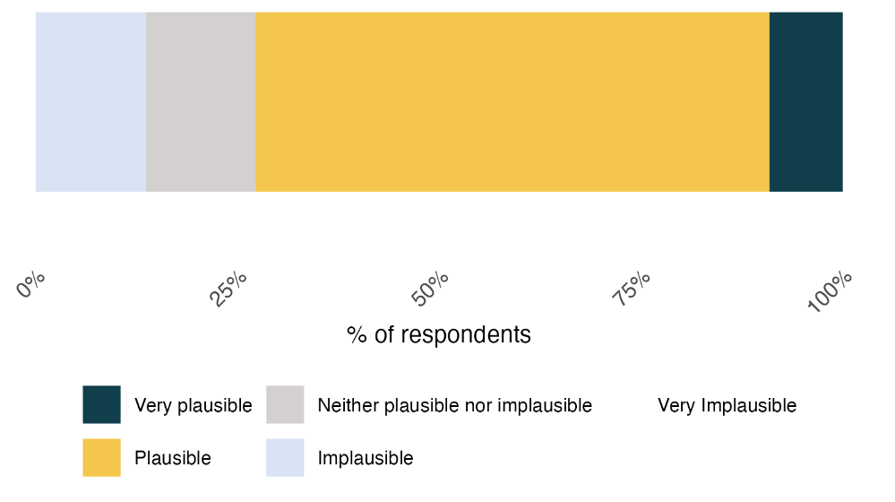
Source: The Network of EU Independent Fiscal Institutions (2026). N=31, including ‘don’t know/unsures’, which are excluded from this figure.
Though a figure showing the IFI plausibility of the net expenditure path was not produced for this edition of the European Fiscal Monitor, IFIs continue to be more generally concerned about the plausibility of the net expenditure path. IFIs point to a variety of drivers behind this increased scepticism. For some, expenditure – most notably public sector wage and compensation increases, as part of ongoing reforms (Slovakia, Croatia, Portugal and Lithuania) – have been higher than initially estimated. For others, the persistence of temporary support measures originally introduced for the 2022-23 energy shock have continued to boost expenditure even as they're nominally ‘temporary’. For example, the Cypriot IFI attributes control-account pressure specifically to the VAT reduction on electricity and fuel excise duty cuts.
Many IFIs tie their concern over the net expenditure path to NEC-activation. The structure of the NEC means that net expenditure, despite being well above originally committed path levels in many countries, is not recorded as deviations in the ‘augmented’ control account. The expiry of the NEC after 2028 implies a sudden ‘cliff-edge’ worsening of the respect of the net expenditure path indicator, driving IFIs’ concern - eight IFIs note this is likely to be a very important risk to fiscal sustainability (Cyprus, Czechia, Germany, Estonia, Finland, Lithuania, Poland, Slovakia). This would require a strong, politically challenging post-NEC fiscal adjustment. The European Fiscal Board also highlight this significant fiscal adjustment, noting it would have to be larger than 1% of GDP in many cases, “well beyond” what is typically considered feasible.

Assessment of the control account
Once a deviation is measured, it is meant to be recorded formally, by the European Commission, in the control account: positive deviations mean the Member State is ‘in credit’, while negative ones leave it ‘in debit’. Member States in the preventive arm may deviate from this account within a defined margin. IFIs were therefore asked to assess the likely control account status in 2026, as well as the outturn data control account status of the previous year (Figure 14).
The control account shows a clear deterioration. For 2025, on outturn data, 12 out of 30 IFIs report their country in credit, five broadly neutral and 12 combined in debit (six within margin, six exceeding it). Moving to 2026 projections, the credit position falls to 10 out of 30, while debit-exceeding-margin rises to eight. As discussed, several IFIs attribute this to specific discretionary measures (Cyprus, Portugal and Slovenia), while for others it is more technical – the Netherlands reports a technical resetting of its baseline following the submission of a new plan this year, changing the ‘2025’ reference figure.
Figure 14. IFIs’ assessment of the control account status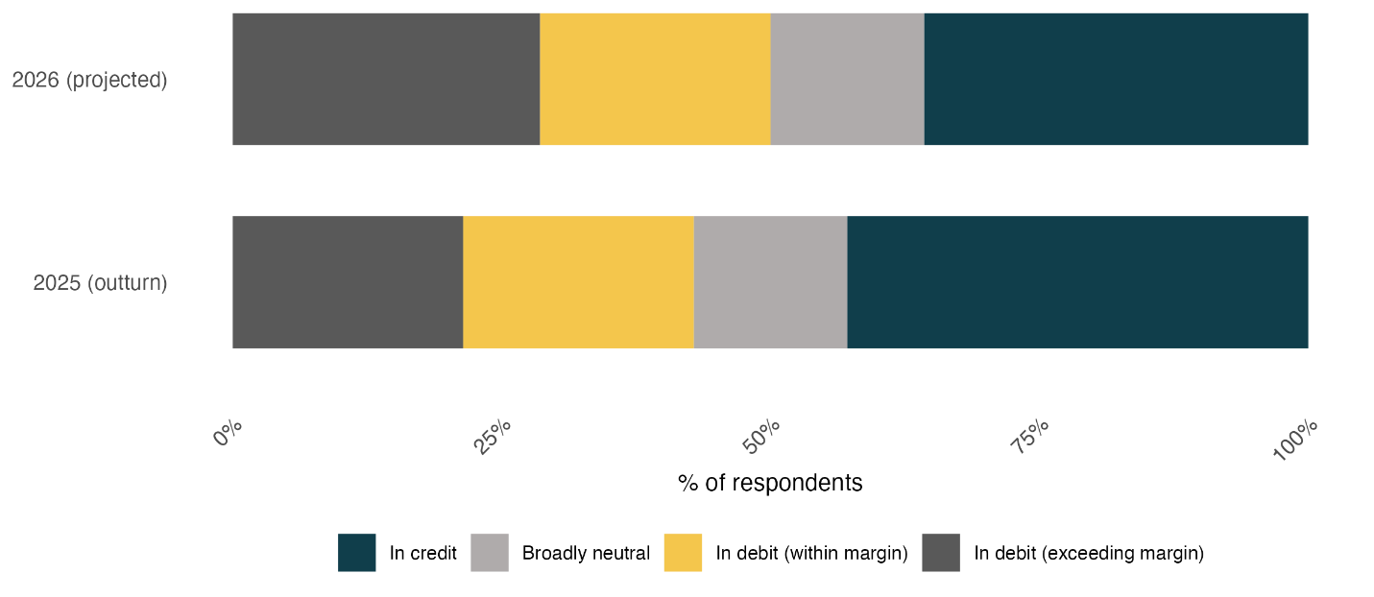
Source: The Network of EU Independent Fiscal Institutions (2026). N=31, including ‘don’t know/unsures’, which are excluded from this figure.
The typical accountability response, at the national level, to a formal deviation is via a ‘comply-or-explain’ mechanism. Of IFI respondents, 10 report having issued an assessment that would have triggered the principle, 12 report having not done so and six report the relevant provisions are not yet in national law or practice at all, a notable transposition gap.
In several cases, the comply-or-explain mechanism appears to work, either owing to national governments subsequently agreeing with and recognising the validity of IFI assessments (Cyprus, Latvia and Portugal), or at least formally responding to them (Slovakia). Yet in other cases, such calls have gone somewhat unheeded. In Slovenia, the IFI called for measures to bring public finances into line with the MTFSP. In response, several temporary revenue-raising measures were introduced for 2026 but were found to be insufficient to bring net expenditure in line with the plan. Early signs suggest the heterogeneity of IFIs’ institutional set-up can complicated this mechanism. In Germany, for example, the Stability Council, advised by the German IFI, has been notably silent on a deficit trajectory which the IFI expects will breach 3% of GDP – with or without the NEC.

Assessing the plan's continued credibility
The cycle’s final stage is perhaps the most important, asking whether the plan itself still holds up and, where it does not, whether anything is moving to correct it. Specifically, article 16(2) of Regulation 2024/1263 requires that Member States’ net expenditure path put government debt on a plausibly downward trajectory by the end of the adjustment period in the current MTFSP, at least ex-ante. IFIs were asked for their opinion on the plausibility of their governments meeting this objective during the implementation period of the MTFSP.
The immediate result is highly worrying: In a third of EU countries (9 of 27) IFIs rate it implausible or very implausible (five implausible, four very implausible) that their country’s debt will be on a downward path by the end of their adjustment period.
Several IFIs offer detailed reasoning for this assessment: Germany states plainly that the MTFSP does not imply a plausible downward trajectory even when fully adhering to the net expenditure path. Slovakia quantifies the same concern precisely: even strict adherence to the path would still be consistent with a 2028 deficit of 5.4% of GDP and debt of 73.3%, up from 61.4% at the end of 2025. Poland cites stock-flow adjustments tied to military procurement cash payments and the absence of a convincing consolidation plan, projecting debt rising to 106% of GDP by 2035. Spain offers a more conditional judgement, distinguishing a plausible path fully compliant with committed targets from an implausible one under a no-policy-change scenario.
Figure 15. IFIs rating the plausibility of public debt following a downward-sloping path as specified in the MTFSP by the end of the adjustment period, over the forecasted debt for 2026-28
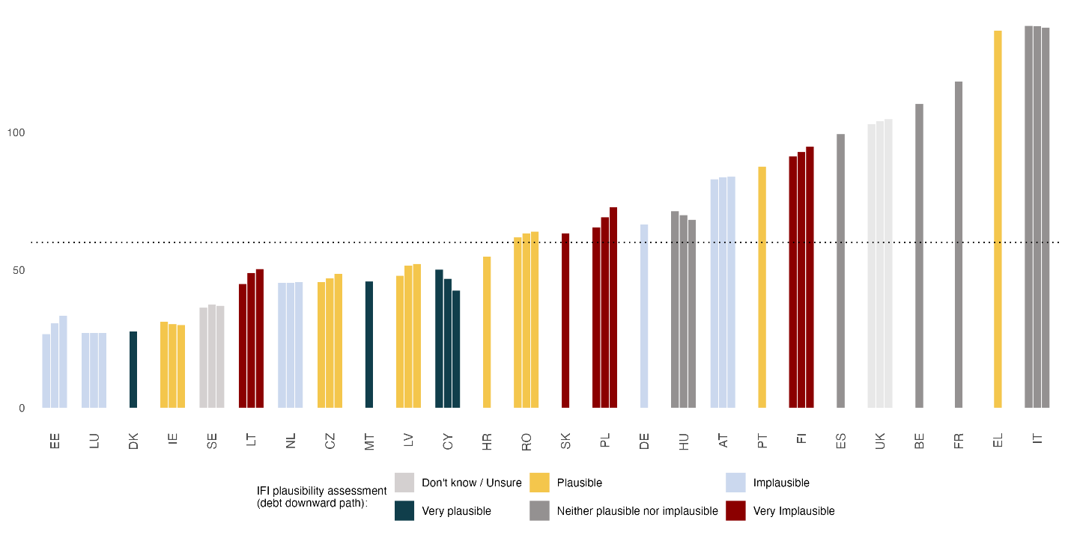
Source: The Network of EU Independent Fiscal Institutions (2026). N=31, including ‘don’t know/unsures’, which are excluded from this figure.
Yet many structural fiscal pressures – demographic ageing, climate adaptation, defence commitments – as noted in the ‘Risks’ section of this Fiscal Monitor, build up over a longer time horizon than the four (up to seven with reforms) year adjustment period. IFIs were thus additionally asked to specify their view on the long-term fiscal sustainability of their country, looking beyond the MTFSP’s adjustment period (Figure 16).
Figure 16. Number of IFIs rating the long-term sustainability of public finances, beyond the current adjustment period
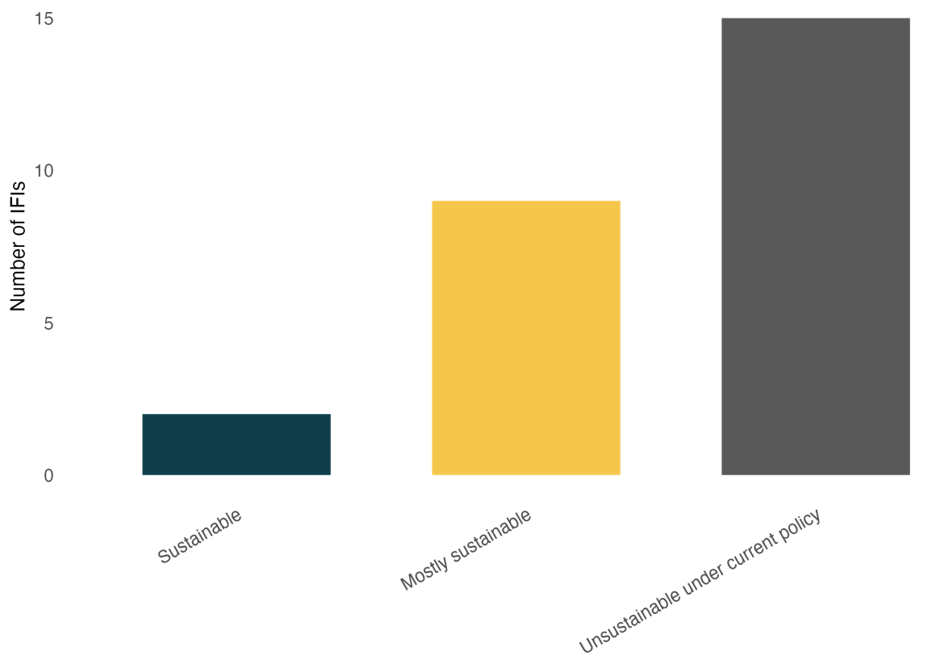
Source: The Network of EU Independent Fiscal Institutions (2026). N=31, including ‘don’t know/unsures’, which are excluded from this figure.
A larger share of IFIs see this long-term horizon as worrying. 16 out of 29 IFIs characterise their country's position as unsustainable under current policy, against nine ‘mostly’ sustainable and only two ‘fully’ sustainable. Two IFIs used the open ‘other’ option to give more nuanced answers rather than picking a category: Malta notes it does not yet conduct long-term sustainability analysis in-house, but points to external assessments flagging high long-term risks from climate change, ageing and demographic pressures. Spain distinguishes between scenarios, noting that compliance with its MTP trajectory would sustain a downward debt path over its forecast horizon, that strict adherence to the accumulated control account (factoring in the NEC) would reverse that trajectory by 2035, and that continuing under current policy conditions would bring the reversal forward.
MTFSPs may also be revised. In extreme cases, the Council may find the plan deficient – if it fails to show that debt is on a plausibly downward path (or the deficit is brought below 3%) – and recommend that the Member State revise its plan. MTFSPs may also be revised for objective circumstances – such as a change of government. Yet the value of MTFSPs is typically that it is not revised, thereby ensuring the path is binding; revision may imply the moving of the fiscal goalposts. IFIs were therefore asked if their country’s MTFSP was expected to be revised over the coming months (Figure 17). Seventeen out of 31 IFIs did not expect any revision, and only nine reported any form of revision in motion (four formally underway, three under discussion, two expected following a change of government).

Figure 17. MTFSP expected revision status
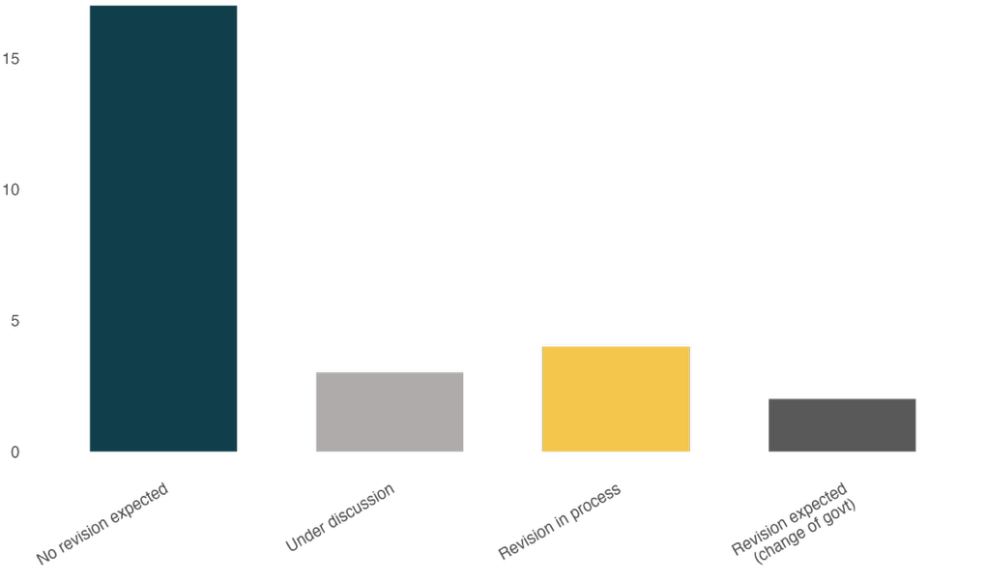
Source: The Network of EU Independent Fiscal Institutions (2026). N=31, including ‘don’t know/unsures’, which are excluded from this figure.
Where revision is happening, it is nearly always tied to a change of government: the Netherlands and Ireland both report new plans following recent elections, the Czech Republic and Hungary both report an incoming government has already requested or is expected to request a new plan, and both Finland and Latvia flag revision as a possibility tied to their own upcoming or recent electoral cycles.

Conclusions
Followed stage by stage, the cycle shows a consistent shape. Reporting quality is uneven rather than uniformly poor, with specific and recurring gaps around net expenditure detail and cross-year comparability. Checking mechanisms are visibly active, with IFIs frequently doing more than the framework formally requires of them, and converge repeatedly on the same weak point regardless of which question is asked: net expenditure growth, with recurring named drivers – wage and pension reforms in Slovenia and Croatia, energy-support measures in Croatia and Cyprus, NEC-shielded defence spending in Poland and Lithuania – appearing again almost verbatim in the accounting stage. Accounting mechanics (the control account and its escape-clause exemptions) appear to be operating as designed, though the comply-or-explain principle appears to play out inconsistently.
Concerns over long-term fiscal sustainability and debt being on a plausibly downward-sloping path imply some plans are appearing no longer adequate without a change in fiscal policy to return to the path. All IFIs anticipating a change in their MTFSP (e.g. in the Netherlands, Ireland, the Czech Republic, Hungary) connect this to a change of government rather than a formal compliance adjustment.

IFI outlook: a first look at fiscal policy responses to the energy price shocks
Following the outbreak of the Iran conflict on 28 February 2026 and the subsequent closure of the Strait of Hormuz, global oil and gas prices rose sharply, and European governments moved quickly to shield households and firms from the impact. This chapter is a first look at that response through the Network's own IFIs. The survey asked for a rough, self-reported estimate of fiscal cost using whatever methodology each IFI had available nationally – there is no shared costing standard behind the figures that follow, and only measures with a reasonably clear, budgeted amount are captured at all. Where possible, this section cross-references IFIs' self-reported figures against Bruegel's independently compiled tracker of the same shock to corroborate findings.

The nature of the response
Measures cluster into two broad types: Price-side interventions – VAT and excise duty cuts, price or margin caps on fuel – and targeted transfers.
IFIs report that price-side interventions dominate by value across European countries. Czech, Polish, Croatian and Cypriot IFIs find this kind of measure as the most common, which is frequently untargeted, and can take the form of daily price caps, margin caps or VAT and excise reductions. Bruegel’s independent tracker estimates that of EUR 11.8 billion committed continent-wide so far, 54% consists of untargeted measures of this kind, corroborating the IFI perspective (see Figure 18). Such a figure requires some nuance; almost by definition, broad-based measures cost more and therefore make up a larger share of the fiscal response, even if pursued by relatively few, but perhaps relatively larger countries. One example is Spain’s large fiscal response – almost half the continent’s total – which includes several untargeted measures, such as a VAT Fuel cut of 50%.
Targeted transfers to specific sectors or households are the second most recurring type, and here a consistent group of sectors comes up repeatedly across otherwise unconnected responses: Transport and haulage, agriculture, and fisheries appear in France, Ireland, Croatia, Cyprus, Portugal and the Netherlands, suggesting a fairly shared, EU-wide sense of which sectors are seen as most exposed to this specific shock. Several IFIs describe measures explicitly targeted at households or vulnerable consumers (Belgium, Croatia, Italy, Denmark and the Netherlands), often taking the form of one-off transfers (Croatia, Italy and Denmark).
This price-side tilt is notable because it runs directly against explicit guidance from the European Commission, and European Central Bank, both cautioning against exactly this kind of broad, untargeted response. Following the 2022 European energy crisis, a series of working papers from international organisations argued that fiscal support, especially given fiscal pressure, would be most effective when conforming to the ‘three Ts’ – timely, temporary, and targeted. In line with this, measures should shift from broad-based relief to narrowly targeted, strictly time-limited measures that preserve the underlying price signal rather than suppress it. The consequence, per Bruegel, is that 86% of the funds committed across Europe actually increase incentives to consume fossil fuels rather than reduce them. The Netherlands is the clearest exception in this survey to that general pattern, pairing household support with an Energy Investment Allowance, heat-pump subsidies and an EV trade-in scheme, incentivising the transition rather than simply offering price relief.
Figure 18. Total cost of targeted vs untargeted measures across the Network
Source: Bruegel (2026), reproduction.

Estimated fiscal impact
IFIs were asked to estimate total costs at the time of the survey (Figure 19). At the low end, Slovakia's measure is described as borne entirely by companies rather than the state; Latvia's excise cut is assessed as fiscally neutral once higher VAT receipts are netted off; Lithuania's is estimated at a fraction of a percentage point of GDP. At the higher end, Malta reports 1% of GDP for 2026 (following 0.7% in 2025) – though this reflects a long-standing universal energy subsidy policy predating this specific shock, not a new energy shock-related measure – and Spain reports commitments of €4.75bn (equivalent to 0.3% of GDP), by far the largest financial commitment, accounting for almost half of the continent-wide total in absolute terms. Such a simple estimate only offers a ‘first glance’ at this evolving situation. Several IFIs are explicit that the fiscal impact is a moving target; distinguishing discretionary measures from broader indirect effects – higher debt-servicing costs, inflation-linked exemptions – is complicated, and it is likely that the eventual total is expected to run ‘well above’ its own headline number if the conflict persists.
Figure 19. Estimated total cost of energy support measures as a percentage of GDP
Source: Network of EU IFIs (2026). In two cases (UK and NL), data was complemented by Bruegel (2026). Ireland reports as % of GNI.

How the cost is being treated
Most IFIs describe their country's measures as temporary or one-off, which is broadly consistent with how governments appear to be managing these costs relative to the net expenditure indicator discussed elsewhere in this Monitor, and consistent with the ‘three Ts’ approach. Yet several IFIs note classification uncertainty. The Czech Republic sets out an explicit quantitative threshold – its excise reduction would tip from ‘routine revenue reduction’ into ‘one-off measure’ territory only once cumulative cost exceeds 0.05% of GDP. Portugal states its measures are temporary but not classified as one-off under the Commission's own definition. Estonia reports the classification simply has not been decided yet.
A smaller group of IFIs report the cost as having no net budgetary effect at all: Italy describes its measures as fully compensated elsewhere in the budget, with zero net impact on borrowing, while Latvia's excise cut is assessed as revenue-neutral once offsetting VAT effects are included. This sits at the opposite end from countries like Malta and Hungary, where the cost is reported as falling directly on the deficit with no offsetting mechanism described.
This chapter establishes a first look at the policy responses to the energy shock brought on by conflict in the Middle East. The response shows there appears to be some European preference for broad-based price-side relief over targeted support, though not without nuance, and a general, if inconsistently applied, instinct to treat these measures as temporary. Cross-referencing against an independent tracker lends confidence to these findings.

Annex – Country factsheets
7.1 NOTE
Country factsheets provide an optional opportunity for national IFIs to provide an overview of their key activities and noteworthy developments in their country over the last six months. This enables a reader to efficiently be brought up to speed on recent developments in this space. Such changes may include new publications, forecasts and other work, changes to the structure, funding and mandate of the IFI, or other, broader developments in legislation relating to IFIs and their work.
Austria
Fiskalrat
The Austrian Fiscal Advisory Council published its fiscal rules compliance report and, according to the latest forecast, expects budget deficits to remain well above the Maastricht threshold of 3% of GDP up to 2030, along with a continuous increase in the public debt ratio to a historic high by 2029. Despite compliance with the net expenditure path, an extension of the excessive deficit procedure is to be expected. This position differs markedly from that of the federal government.
In addition, the Office published notes on the budget impact of possible consolidation measures and on reform options for ensuring the long-term financial sustainability of the Austrian healthcare system. Notes are available here.
The transposition of the revised Budgetary Framework Directive has now been completed. Based on the amendment to the Fiscal Advisory Council and Productivity Board Act, the law includes a new task (i.e. the assessment of the national fiscal framework), the need for an independent external review of the IFI every five years and an additional provision that generally requires participation in parliamentary sessions upon invitation by the National Council.
Belgium
Federal Planning Bureau
The Federal Planning Bureau has published its medium-term macroeconomic forecasts (available here).
High Council of Finance — Public Sector Borrowing Requirement (PSBR) Section
The Section's work will be strongly affected by the ongoing revision of the Belgian internal budgetary framework. A new cooperation agreement on economic governance, replacing the agreement of 13 December 2013, together with adjustments to the Royal Decree of 23 May 2018 on the High Council of Finance, will strengthen the Section's role. Additional resources will also be allocated to the Federal Planning Bureau to house the Section's expanded secretariat.
Croatia
No update was submitted for this cycle.
Cyprus
Fiscal Council of Cyprus
The Fiscal Council has advanced several legislative, analytical and outreach initiatives over the past six months. On the legislative side, it provided recommendations to the Ministry of Finance on revising the Fiscal Responsibility Framework (Law 20(I)/2014) and on the transposition of Directive (EU) 2024/1265, including a new national rule requiring a balanced or surplus structural primary balance each year — an additional safeguard beyond EU requirements — approved by Parliament as Law 90(I)/2026 in April 2026.
In February 2026, the Council co-hosted the EU IFI Network's thematic conference, “Fiscal Management in Changing Times: The Initial Responses,” and co-launched, with the Cyprus Public Service Employees Union (PASYDY), an initiative inviting public sector staff to propose bureaucracy-reducing simplifications, with awards presented in April 2026.
Recent publications include work on planned projects and activities for 2025–2028, on the budget and Cyprus' need for self-protection, on proposed tax differentiations, and on inelastic expenditures. At EU level, the Council remained active in the Technical Support Instrument project, contributing to sustainability analysis tool mapping and long-term fiscal and climate risk work, including developing its own debt sustainability analysis model. Core mandate work over the period centred on the macro-fiscal endorsement of the 2026–2029 framework, monitoring risks to the net primary expenditure path, and assessing the fiscal sustainability implications of the 2026 Tax Reform.
Czech Republic
Czech Fiscal Council
In May 2026, the Chamber of Deputies approved Document No. 90/0 (available here, in Czech only), a government bill amending several acts relating to public budgets. The bill incorporates into Act No. 23/2017 the changes required by Directive (EU) 2024/1265 — including publication of the national fiscal-structural plan and Annual Progress Report, and a modest strengthening of the Fiscal Council's role.
The bill also relaxes budgetary discipline in several respects, via largely non-transparent amendments to Act No. 218/2000 (the Budgetary Rules Act): a 10% allowance to exceed total expenditure limits during a declared national emergency; an extension, from 2033 to 2036, of the exemption for defence spending above 2% of GDP; an expansion, for 2026–2036, of the escape clause to cover infrastructure construction and PPP availability payments; use of the prior year's primary structural balance result when setting the expenditure framework, regardless of its compliance with the rules; a proposed (not yet approved) suspension of fiscal responsibility rules when the Chamber of Deputies returns the draft state budget for revision; and the exclusion of new nuclear power plant financing, to be routed via the Ministry of Industry and Trade, from the general government debt calculation.
As of 2 June 2026, these changes had not yet been approved by the Senate, and their final legal wording remains unsettled; the bill is currently available only as a Senate print (available here).
Denmark
No update was submitted for this cycle.
Estonia
Estonian Fiscal Council
Transposition of the EU Directive required amending the Estonian State Budget Act, including the tasks and obligations of the Fiscal Council. These new tasks have since been reflected in the Council's own mandate and on its website.
Finland
Economic Policy Council
The Council published its annual report in February 2026, has given several statements to Parliament, and endorsed the government's macro forecast in spring 2026. It is currently preparing its assessment of corrective actions related to the Excessive Deficit Procedure. Its mandate has also changed: it has been assigned the role of Finland's independent fiscal institution, has added three economists to its secretariat, and has received a budget increase of €300,000.
France
Haut Conseil des finances publiques (HCFP)
The 2026 budget was adopted under Article 49.3, raising the deficit target from -4.7% to -5.0% of GDP. The government's GDP growth assumption was subsequently revised down from 1.0% to 0.9% in the April Annual Progress Report, reflecting the conflict in the Middle East; this remains above the European Commission's and Consensus Forecasts' estimate of 0.8% for 2026.
The HCFP issued three opinions over the period. On the updated Military Programming Law (2024–2030), it noted the additional defence effort is significant (€36 billion over five years, over 1% of GDP), extends beyond 2030, and reduces fiscal space for other spending. On the 2025 draft budget settlement bill, it observed that the decline in the public deficit (-5.1 percentage points of GDP) was driven mainly by higher taxes and compulsory levies, with expenditure continuing to grow slightly faster than GDP. On France's Annual Progress Report under the MTP, it regretted insufficient information on the scale and composition of measures to offset the cost of the Middle East conflict, while noting the 2026 macroeconomic scenario was consistent with assumed energy prices but remained exposed to external uncertainty.
The Secretariat also published an analysis of tax forecasting methods, setting out the tools the HCFP uses to analyse tax developments and assess forecasts, and stressing the role of growth composition and macroeconomic assumptions in driving short-term tax revenue.
Germany
Advisory Board of the Stability Council
The Advisory Board has published its 25th statement (available here, currently available in German only).
Greece
Hellenic Fiscal Council (HFISC)
The Council has published its Assessment of the Annual Progress Report 2026.
Hungary
Fiscal Council
In December 2025, the Fiscal Council published its three-year outlook, including an assessment of MTFSP implementation. In April 2026, it published its semi-annual report on the implementation of the 2025 budget.
Ireland
No update was submitted for this cycle.
Italy
Ufficio Parlamentare di Bilancio (UPB)
Between December 2025 and May 2026, the UPB gave two parliamentary hearings — on the 2026 Public Finance Document, and on the delegation to Government to determine minimum guaranteed levels of public service performance nationwide — and endorsed the macroeconomic projections in the 2026 Public Finance Document on 8 April 2026. Over the same period it published two of its four annual Reports on Recent Economic Developments, three Focus papers and one Flash paper, covering public and private healthcare funding and delivery, the macroeconomic and public finance outlooks in euro area countries' 2026 draft budgetary plans, an analysis of the final 2026 budget texts, and the sixth revision of the NRRP and its impact on net borrowing.
The UPB's first external peer review was published by the OECD in March 2026. Its annual funding from Parliament rose from €6 million to €7 million from 2025 (against a request for a further €2 million), but the UPB spent its full 2026 endowment, and a further increase is needed.
Latvia
Fiscal Discipline Council
The Council has a new chairman and two new board members.
Lithuania
National Audit Office (IFI function)
The National Audit Office has published its opinion on the economic development scenario.
An updated fiscal governance framework came into force in Lithuania in 2026, aligning national rules with the new EU fiscal framework. Net expenditure is now the key indicator of fiscal discipline, with its permitted annual growth depending on the level of public debt and deficit and on the application of EU recommendations; local authorities have also been given greater budgeting flexibility. The role of the independent fiscal institution — carried out by the National Audit Office — has been strengthened, the comply-or-explain principle has been enshrined in fiscal governance, and it is now entrenched in law that the National Audit Office serves as both supreme audit institution and independent fiscal institution.
Luxembourg
No update was submitted for this cycle.
Malta
Malta Fiscal Advisory Council (MFAC)
In 2026 to date, the MFAC has published three reports: its letter of endorsement for the national Medium-Term Fiscal Strategy 2025–2028; its Annual Report for 2025, covering the year's activities and including thematic chapters on a new macroeconomic heatmap for the Maltese economy and on the evolution of government expenditure by COFOG category; and its endorsement letter for the macro forecasts in the 2026 Annual Progress Report, judging them within the Council's deemed-endorsable range while noting differing views on aspects of growth composition — particularly investment and general government final consumption expenditure — and expressing concern about potential output growth. Detailed macroeconomic and fiscal assessment reports on the 2026 APR are in preparation.
These reports can be accessed here. Malta held a general election on 30 May 2026, which did not result in a change of government. The MFAC continued developing an integrated macroeconomic-fiscal model to strengthen its assessment of government forecasts, supported by the Technical Support Instrument programme. Uncertainty remains, however, since Directive (EU) 2024/1265 had not been transposed into national legislation during 2025 or the early months of 2026; the MFAC remains committed to engaging with stakeholders to help formulate the necessary legislative amendments.
Netherlands
CPB Netherlands Bureau for Economic Policy Analysis
The CPB published its Central Economic Plan forecast in March 2026, covering the macroeconomic and fiscal outlook to 2034. It also published an analysis of the Coalition Agreement in February 2026, assessing the macro and fiscal effects of the incoming cabinet's plans, following the same process used for party manifestos.
The CPB's other recent work includes an analysis of the effects of higher energy prices on purchasing power and growth, published in April, and a study of car taxation and the tapering of the youngtimer vehicle tax scheme.
Poland
Fiscal Council
The Council has focused its first months on building its Secretariat, which now comprises eight analysts responsible for fiscal and macroeconomic analysis and projections. The first quarter of 2026 involved intensive dialogue with the Ministry of Finance over the Council's budget: rather than a separate budget chapter, a government “reserve” line was created, with spending from it subject to Ministry approval, raising questions over staffing and procurement.
The Council held its first meeting in January 2026 and has met at least monthly since, supplemented by online meetings as needed. Its first accomplished tasks include its first statutory opinion on government macroeconomic projections, own-initiative opinions — including on government measures to counter rising energy prices — and a presentation of its position on the government's draft act amending the fiscal rule to parliamentary committees.
The Council continues to seek improved access to information from the Ministry of Finance, which has, for example, declined to share information needed to assess the draft fiscal rule amendment, citing the Council's lack of mandate. Draft memoranda of understanding are under discussion with the Central Statistical Office and the State Audit Office, and one has been prepared with the Ministry of Finance. The Council expects to launch its website shortly.
Portugal
Conselho das Finanças Públicas (CFP)
The CFP has published its Economic and Fiscal Outlook 2026–2030.
Romania
Fiscal Council
The Fiscal Council has published its opinion on the 2026 budget. Separately, Fiscal Responsibility Law 69/2010 was updated in 2026, enlarging the Council's mandate to bring it into line with Regulation (EU) 2024/1263.
Slovakia
Council for Budget Responsibility (CBR)
Over the past six months, the CBR has published an addendum to its evaluation of the 2026–2028 general government budget, its 2025 general government budget results, its Report on the Long-Term Sustainability of Public Finances for 2025, its assessment of compliance with 2025 expenditure ceilings, and its assessment of the 2026 Annual Progress Report. The CBR also continues to publish its monthly Budgetary Traffic Lights forecast.
Slovenia
Fiscal Council of the Republic of Slovenia
The Council has published its Assessment of the Annual Progress Report (April 2026, English translation), which shows actual net expenditure growth against the MTFSP and the resulting control account, and includes an assessment of the potential public finance implications of the war in Iran based on the ECB's March forecast scenarios.
Institute of Macroeconomic Analysis and Development (IMAD)
IMAD has published its Spring Forecast of Economic Trends 2026 and its Development Report, which monitors Slovenia's development and highlights the main issues facing the Slovenian economy and society going forward.
Spain
AIReF
In March 2026, the six-year term of AIReF's previous Chair, Ms Cristina Herrero, came to an end; she was succeeded by Ms Inés Olóndriz. A draft central government budget for 2026 has not been presented, and, among the Autonomous Regions, 8 of 17 do not yet have approved 2026 budgets and are operating on carried-over budgets.
Sweden
No update was submitted for this cycle.
United Kingdom
No update was submitted for this cycle.

For more, see the CFC’s analysis in the Czech Republic’s country factsheet at the end of this report.
The control account tracks cumulative observed deviations from the recommended net expenditure path (as described in Article 22 of Regulation 2024/1263), based on outturn data. The augmented control account is for Member States with an active NEC, and operates similarly, but only registers deviations from that path that exceed the flexibility granted by the NEC. For more information, see Box 1 of the latest fiscal statistical tables from the European Commission.
European Fiscal Board (2026) The implementation of national medium-term fiscal-structural plans: Recent fiscal developments and draft budgetary plans for 2026, Brussels, [accessed 05.07.2026]
By means of example, see: International Monetary Fund (2026), ‘Responding to the Energy and Food Price Shock: Getting the Policy Details Right,’ IMF Blog, 20 May 2026 [accessed 9.07.26]

